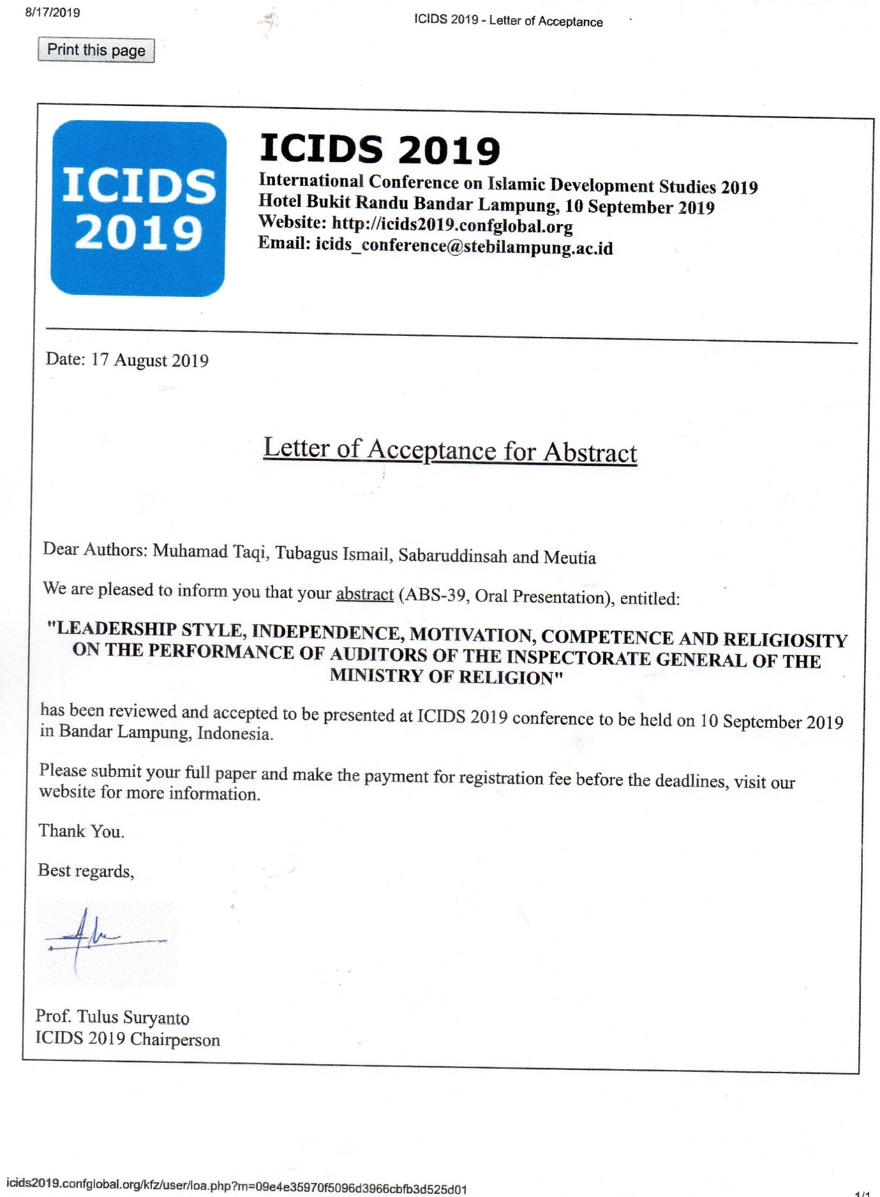

The First International Conference
on Islamic Development Studies
ICIDS September 10th,2019

Wednesday, September 4st 2019

Dears Author,

We are pleased to inform you that your abstract has been reviewed and accepted to be presented
at The First International Conference on Islamic Development Studies (ICIDS) 2019 to be held
on September 10th, 2019 in Bukit Randu Hotel Bandar Lampung.

We cordially invite you to attend our conference and present your research.

Submission final decision is undecided because your full paper will go throught a review process
on ICIDS 2019 and be presented in Parallel Session ICIDS 2019 at Bukit Randu, September 10th,
2019. After the conference you will be given 2 week for revision and then your article will be
reviewed further by the reviewer.

You must be send camera paper (power point presentation) with maximum 15 slide. Send your
camera paper to committee by email icids_conference@stebilampung.ac.id maximum on
September 7th, 2019.

Sincerely yours,

Dr. Reza Ronaldo
Chair

